Urbanization affects web abundance and aggregation of a funnel-weaving spider, *Agelenopsis pennsylvanica*

Brandi J. Pessman 1*, Madison Hays 1, Earl Agpawa 2, Eileen A. Hebets 1

1 University of Nebraska-Lincoln, Department of Biological Sciences, Lincoln, Nebraska, United States

2 University of Nebraska-Lincoln, Department of Entomology, Lincoln, Nebraska, United States

* Corresponding Author Email: [bjpessman@gmail.com](mailto:bjpessman@gmail.com)

## Abstract

Animals distribute themselves within habitats based on a variety of environmental conditions, including those impacted by urbanization. Throughout North America, funnel-weaving spiders (*Agelenopsis*) are prevalent across urban habitats and actively choose sites to build webs. We compared *A. pennsylvanica* abundance and distribution between two distinct urban habitats: an urban center (university campus) and an urban forest (city park). These urban habitats differ significantly in terms of plant diversity and disturbance from nearby roads and highways, among other factors. We wanted to know how these urban habitats and their associated environmental conditions affect *A. pennsylvanica* spatial patterns. We searched along paths from randomly selected start sites in each habitat until we found the first occupied (focal) web. We measured web and spider abundance, distances between the focal and two nearest-neighbor webs, and web height in a ten-meter radius. We found that (i) search distances to focal webs were shorter, and both (ii) webs and (iii) spiders were more abundant in the urban center than in the urban forest, despite less diverse plants for web structures in the urban center. We also found (iv) shorter distances between webs and (v) lower web heights in the urban center. Generally, spiders were more abundant and aggregated at sites that had lower plant diversity and greater disturbance from road and highway traffic. Our data suggest that *A. pennsylvanica* spatially distribute themselves differently across different urban habitats, and this variation relates, in part, to differences in environmental conditions.

## Keywords

Arachnids, Arthropods, Spatial Distribution, Environmental Predictors

## Acknowledgments

We thank Morgan Ryan for his advice about processing the GIS data in QGIS. We are grateful for past and present members of the Hebets, Shizuka, and Keesey labs (UNL Behavior Group) for their feedback on data analysis and earlier drafts of the manuscript. We also thank conference attendees that have visited posters and oral talks about this project, as those conversations have helped to improve many aspects of the research presented here.

## Introduction

Animal abundance and distribution are influenced by combinations of environmental factors, intra- and interspecific interactions, and dispersal capacity (Diez & Pulliam, 2007; Svamberkova & Leps, 2020). Environmental factors, including climatic conditions, land cover, habitat heterogeneity, and access to certain resources (like water and shelter), are suspected to relate to physiological constraints that limit the fundamental niche (Chase & Leibold, 2003). Interactions within species (between conspecific competitors and mates) and across species (with predators, prey, and heterospecific competitors) further shape animal spatial patterns (Anderson, 2017; Boulangeat et al., 2012). While dispersal capacity can determine a species’ range, barriers can limit dispersal and prevent animals from reaching suitable habitats (Amundrud et al., 2018; Boulangeat et al., 2012).

Aggregations can form when suitable conditions and resources are not evenly distributed, leading to higher-quality patches (Churchill et al., 2020). For example, gaps in the tree canopy allow more sunlight to reach the understory – thus, increasing plant height and soil moisture and decreasing leaf litter – causing some invertebrate families to become more abundant in these patches (Perry et al., 2018). Clumping can also result from incomplete dispersal that occurs when barriers, often due to habitat structure, prevent adequate dispersal (Riechert, 1974a). Scientists have found differences in the relative importance of different spatial predictors based on the type of taxon-specific spatial information collected – *i.e.* presence, abundance, aggregation, or vertical position (Boulangeat et al., 2012).

Due to intense habitat disturbance and dense human presence, urbanization has drastically modified the land (Alberti et al., 2020; McDonnell & Pickett, 1990; Pickett et al., 2001). These land changes lead to altered environmental conditions, community dynamics, and dispersal capability as a result (Piano et al., 2020). Urban environments are characterized by decreased biodiversity (McKinney, 2002), increased impervious cover (compacted soil from buildings and pavement, Nowak & Greenfield, 2020), habitat patchiness (Cadenasso et al., 2007), pollution (air, water, and light, Grimm et al., 2008; Hopkins et al., 2018), and noise (air-, water-, and substrate-borne, Barber et al., 2010; Slabbekoorn et al., 2010; Wu & Elias, 2014). These conditions can contribute to changes in local climatic conditions, such as when impervious cover traps heat and increases the average temperatures in cities compared to surrounding areas — *i.e.*, the Urban Heat Island Effect (Morabito et al., 2021). There is growing evidence that urbanization changes species interactions, even reshaping whole food webs (Start et al., 2020) and altering the landscape of parasite and disease transmission (Bradley & Altizer, 2007). As many of these conditions and dynamics determine animal spatial patterns, it is likely that urbanized landscapes have changed how animals spatially distribute themselves.

Urban ecosystems can also be extremely heterogeneous with unique and diverse habitats nested within (Rivkin et al., 2019). For example, habitats within urban ecosystems can differ considerably in landscape features (e.g. tree and building cover), weather conditions (e.g. temperature, humidity, and wind speed), and disturbance, resulting in variable access and distributions of resources and opportunities for certain species to thrive. These factors can also differentially drive animal spatial patterns (Murray et al., 2019; Trubl et al., 2012), sometimes leading to higher degrees of aggregation for urban animals (M. T. J. Johnson & Munshi-South, 2017).

Variation in the abundance and distribution of urban arthropods can have implications for ecosystem function due to the essential ecosystem services that arthropods provide, like pest control (Otoshi et al., 2015) and pollination (Ivers et al., 2022). Arthropods are considered critical bioindicators of ecosystem health as their short generation time requires them to respond rapidly to human-induced change (McIntyre, 2000). However, the impact of urbanization on arthropod ecology is still understudied (Fenoglio et al., 2020; but see Kotze et al., 2011), and the relationship between urban habitats and arthropod abundance and diversity remain controversial (Dale & Frank, 2018; Gippet et al., 2017). Such discrepancies are most likely due to abundance and distributions being species- (Gippet et al., 2017), habitat- (Bennett & Lovell, 2014), and scale-dependent (Philpott et al., 2014). While some animals benefit from urban conditions (Guenard et al., 2015), many cannot survive the disturbance and change associated with cities (Wagner, 2020). Thus, it is important to determine how urban factors contribute to variation in arthropod abundance and spatial patterns for the conservation of arthropods and their essential services.

Spiders, specifically, play an important role in pest control. They are predicted to collectively consume up to 800 million tons of arthropods each year (Nyffeler & Birkhofer, 2017). Previous studies have found that factors that vary across urban habitats may drive differences in spider spatial distribution, including prey abundance (Riechert & Tracy, 1975; Trubl et al., 2012), noise (J. P. Bunkley et al., 2017; Gomes et al., 2020), pollution (Żmudzki & Laskowski, 2012), fragmentation (Stefani & Del-Claro, 2015), microclimate conditions (Riechert & Tracy, 1975), vegetation structure (Peng et al., 2020), and suitable web substrates (Chan et al., 2009). Random spacing in solitary spiders is typically maintained by territoriality and aggression over resources like prey and mates (Riechert, 1974a), but occasionally, conditions arise that allow solitary spiders to become more tolerant of neighbors. The mechanisms behind non-social spider aggregations - especially in urban habitats - are unclear. Nonetheless, there are reports of aggregations of spiders in urban habitats, such as the web-building spiders *Lactrodectus hesperus* and *Brigittea civica* (J. C. Johnson et al., 2012; Mammola et al., 2018). A more thorough understanding of how and why various species of spiders might distribute themselves differently in urban settings is important, as urban spider aggregations can have medical and aesthetic consequences, as well as implications for urban pest control services.

Funnel-weaving spiders in the genus *Agelenopsis* are found across North America and can be locally very common. They actively select web locations based on experience of perceived quality of the site (Riechert, 1976) and are thus likely impacted by environmental conditions resulting from urbanization. Prey abundance, available web substrates, vegetation structure, and microclimate conditions have been shown to be indicators of a quality web site in a desert habitat for *A. aperta* (Riechert et al., 1973; Riechert, 1974b). *Agelenopsis pennsylvanica* is a non-desert dwelling relative that similarly builds webs consisting of a sheet that functions as a prey capture area and a retreat to escape from predators and unfavorable conditions (Fig. 1), such as direct sunlight (Riechert & Tracy, 1975). The horizontal sheet is not sticky, and the web is used solely for its vibratory properties to rapidly and accurately alert the spider to prey that fall upon or walk across the web (Singer et al., 2000).

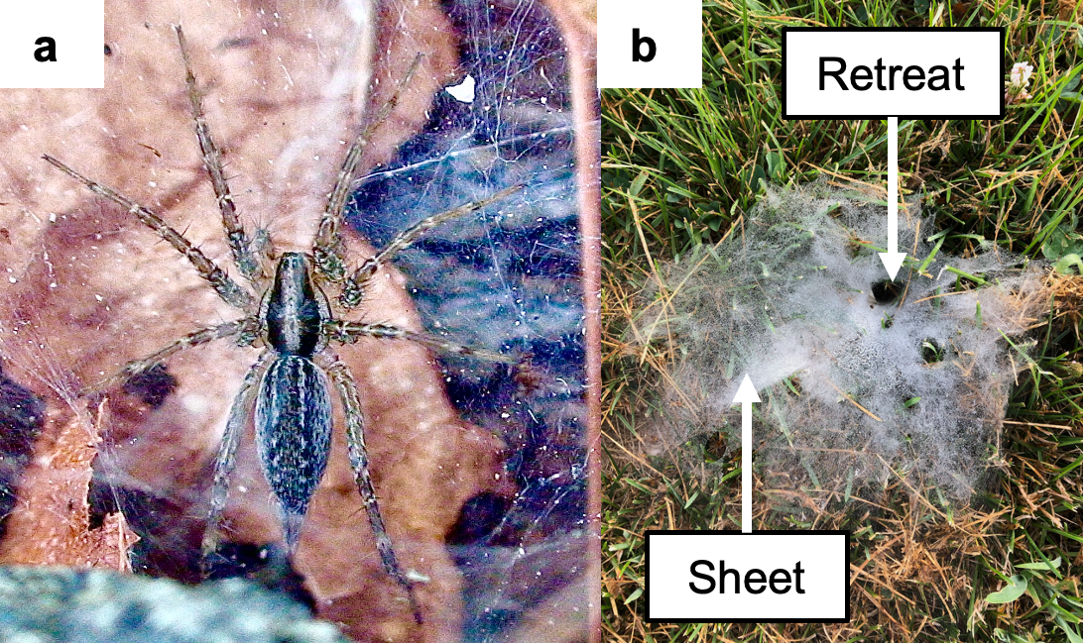

**Fig. 1** Study System - *Agelenopsis pennsylvanica* (a). The web consists of a retreat where the spider waits for prey to land, fall, or walk on the web sheet (b)

To understand habitat characteristics that might influence the distribution of *A pennsylvanica* across urban environments, we compared *A. pennsylvanica* spatial patterns between two urban habitats (an urban center and an urban forest). In particular, we asked the following three questions: (*i*) How do environmental conditions vary between two urban habitats? (*ii*) How do *A. pennsylvanica* web abundance, aggregation, and position vary between these two urban habitats? (*iii*) What environmental variables help predict spider spatial patterns in distinct urban habitats? Based on preliminary observations, we predicted that *A. pennsylvanica* would be more abundant and aggregated in the urban center than the urban forest. We further expected that specific environmental conditions that vary between the two habitats (e.g. tree cover, plant species richness, and disturbance from roads) would be correlated with the variation in the spatial patterns of *A. pennsylvanica*.

## Material and methods

We conducted our study in September and October of 2020 in Lincoln, Nebraska, USA. Lincoln – with a population of about 300,000 people (*QuickFacts*, 2020) – has diverse urban habitats that vary in the degree of disturbance, management, and plant cover. We compared the abundance, aggregation, and position of funnel webs of the spider *Agelenopsis pennsylvanica* between two urban habitats: the University of Nebraska-Lincoln (UNL) City Campus (an urban center) and Wilderness Park (an urban forest) (Fig. 2, Fig. S1). These two habitats were selected due to their distinctive characteristics (described below), preliminary observations of potential differences in funnel-weaving spider abundance and aggregation (Fig. S2), and ease of access.

*Urban Center* - We defined the study boundaries of UNL City Campus as Salt Creek Roadway, North Antelope Valley Parkway, North 10th Street, and Q Street (1.12 $km^{2}$, Fig. 2, Fig. S1). UNL City Campus is adjacent to, and just north of, downtown Lincoln (253.73 $km^{2}$). Lawns are maintained by frequent mowing, and gardens and landscaping are regularly pruned. There was heavy foot traffic from UNL’s 20,286 undergraduates enrolled in the 2020-2021 academic year, 37% of which lived in college-owned, -operated, or -affiliated housing (UNL Office of Institutional Effectiveness and Analytics, 2021).

*Urban Forest* - Wilderness Park is a stretch of forested land (6.44 $km^{2}$, Fig. 2, Fig. S1) starting about 3.58 km southwest of UNL City Campus and downtown Lincoln, extending south and along Lincoln city limits. Wilderness Park has about 18 kilometers of dirt trails, dense deciduous tree growth, and variable undergrowth. The trails are open for recreational walking, running, biking, and horse riding. While we found no public records of the number of visitors to Wilderness Park, trail-goers were infrequent during data collection.

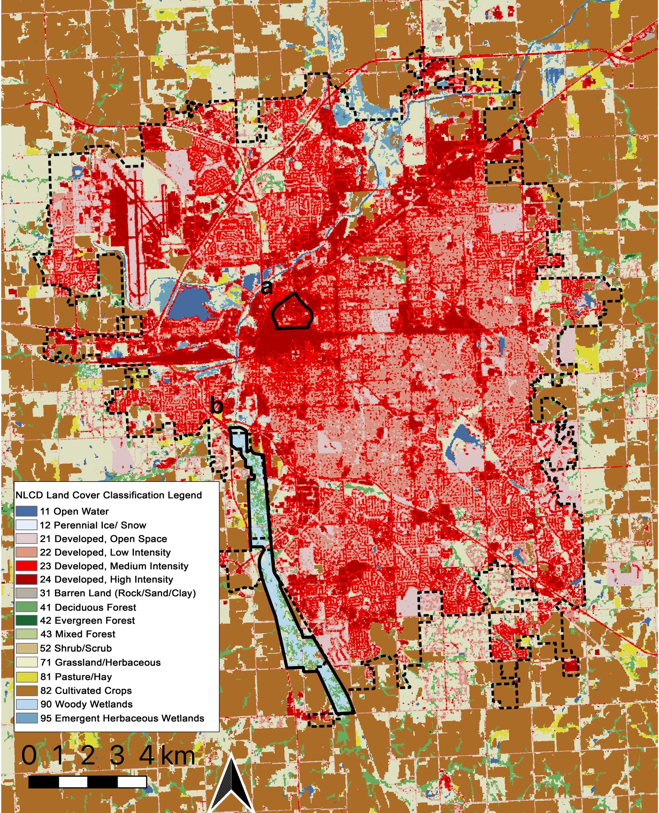

**Fig. 2** Land cover raster with borders for Lincoln, Nebraska, USA city limits (dashed border), University of Nebraska-Lincoln (UNL) City Campus (Urban Center, solid border, a), and Wilderness Park (Urban Forest, solid border, b) using the 2019 National Land Cover Data on Land Cover and QGIS (v. 3.16.3-Hannover, ESRI 102704). For visualization and listing of study sites, see Figure S1 and Table S1, respectively

### Study sites

To select random survey sites in each of the two habitats, we assigned numbers to each intersection of roads and sidewalks that meet from the four cardinal directions in the urban center and to intersections of three or more trails in the urban forest (Fig. S3). We used a random number generator to randomly select 12 intersections in the urban center and 10 intersections in the urban forest as start sites (Table S1). We marked the GPS coordinates of these locations using a GPS receiver (Magellan SporTrak Map, Model 980616-01, Parsippany, New Jersey, USA).

From each start site, we began walking along a path in a randomly selected direction (North, East, South, or West using a random number generator). We conducted a thorough visual search of the edges of the path for *A. pennsylvanica* funnel webs as the GPS receiver tracked our movement (Fig. S4). We walked along pre-existing sidewalks, roads, and trails because paths were a common feature of both habitats along which we had previously found funnel-weaving spiders. We often found *A. pennsylvanica* in edge habitats in the study region, and this tendency to build webs at a habitat’s edge is shared by other spider species (Cobbold & Supp, 2012). Additionally, the thick undergrowth of the urban forest often restricted searches off the trails. To ensure equivalent search efforts, we took more time searching the edge of dense undergrowth in the urban forest.

*Focal web* – When we reached a funnel web, we checked to see if the web was occupied by a spider. We did this by resting a toothpick secured to the bristled end of a vibrating toothbrush on the sheet of the web. We turned on the electric toothbrush to simulate prey in the web. If a spider emerged, we noted this web as the *focal web*. If no spider emerged after 30 seconds, we continued searching until we found an occupied funnel web. Preliminary trials demonstrated this to be an effective means of enticing a spider out of its retreat and onto its sheet web. We used the GPS receiver to mark the coordinates of the focal web. Although it is possible that other species of *Agelenopsis* are present in Lincoln, we have only found *A. pennsylvanica* during surveys in the area.

### Urban habitat characteristics

*Environmental conditions of the habitats and Lincoln* – We first compared differences in environmental conditions across our two selected urban habitats and Lincoln city limits. We chose tree cover, impervious cover, and land cover class for this initial analysis to capture the degree of variation between the habitats as compared to the entire city. We gathered and analyzed Geographic Information Systems (GIS) data in QGIS (v. 3.16.3-Hannover, ESRI 102704). We obtained tree cover (U.S. Forest Service, 2016), impervious cover (building and pavement, U.S. Geological Survey, 2019b), and land cover class (U.S. Geological Survey, 2019a) from the National Land Cover Database (30-meter resolution). We polygonized the tiff files and calculated the average value for each factor by location using the boundaries described above: urban center (UNL City Campus), urban forest (Wilderness Park), and Lincoln City Limits (see Fig. 2, Fig. S5-S8). We calculated the averages using the following equation:

$$average=\frac{\sum_{i=a}^{b}{i*x_{i}}}{100}$$

Where *i* is the value indicated by the pixel (with range b-a) and $x_{i}$ is the percent of the habitat covered by the $i^{\left(th\right)}$ pixel category.

*Environmental variables between habitats* – To add environmental variables for a more detailed comparison of these two habitats, we collected nine total environmental predictors from each study site: (1) tree cover, (2) impervious cover (percent developed surface), (3) thermal conditions (spectral radiance), (4) light at night radiance, (5) plant species richness, (6) patch area (area of continuous vegetation), (7) disturbance from roads, (8) disturbance from highways, and (9) total road length. All measurements except plant species richness were completed in QGIS (v. 3.16.3-Hannover, ESRI 102704).

We recorded the percent tree cover (1) and impervious cover (2) at each site using the polyganized tiff files described above. To collect spectral radiance (3) – a measure of thermal conditions on Earth’s surface, we used an image from path 28, row 32 of the Landsat-7 World Reference System-2 (Band 6, 30-meter resolution, taken on September 2, 2020). We assessed artificial light at night levels (4) using the 2020 Visible Infrared Imaging Radiometer Suite (VIIRS) from <https://www.lightpollutionmap.info/> (500-meter resolution). We analyzed these measures in 100-meter buffers around each focal web. We used a 100-meter buffer to accommodate the resolution of the GIS data. We refrained from including a larger buffer region as the dispersal range of this system is unknown and may be dependent on barriers present in the habitat.

We collected plant species richness (5) on-site by recording each unique plant species (using a plant identification phone application - PictureThis) found in a ten-meter radius of the focal web at each study site (Fig. S9). We measured patch area (6) using satellite imagery to define the area of continuous vegetation at each study site. Roads, sidewalks, and trails were defined as fragment boundaries. To determine the potential disturbance from road (7) and highway traffic (8), we first measured the shortest distance from each focal web to the nearest road (GIS vector from: Private Member, 2021) and highway (GIS vector from: Private Member, 2019) using the NNJoin Plugin (Tveite, 2019) for QGIS. We used the 2021 Average Daily Traffic Volume report (City of Lincoln Transportation & Utilities, 2021) to identify the average daily number of vehicles to travel on each nearest road and highway. We divided the average daily traffic by the shortest distance from the focal web to the nearest road and highway (as in Dooley & Brown, 2020) for metrics of road disturbance and highway disturbance, respectively. Lastly, we measured the total length of road (9, Private Member, 2021) within a 100-meter buffer of each study site.

### Spider web abundance, patterns, and positions

To determine differences in spider web abundance, aggregation, and position between the two urban habitats, we completed each of the following measurements at each study site within a ten-meter radius of the focal web.

*Spider Abundance* – Search distance can often be used to estimate abundance (Buckland et al., 2005), as spiders are likely less abundant in an area where we need to search further from the path intersection to the focal web. Thus, we use search distance as evidence for variation in abundance. To quantitatively determine the abundance of webs and spiders near each focal web, we measured a ten-meter radius around the focal web and counted the number of occupied and unoccupied webs. We used the same methods (using the electric toothbrush) as those used for determining the presence/absence of the focal spider.

*Spider Aggregation* – We assessed nearest neighbor distances as a measure of aggregation behavior. Starting at the focal web and working outwards, we marked the locations of the two webs (including occupied and unoccupied) nearest to the focal web and within ten meters. We limited our measurements to the nearest two webs because we often found no more than three webs (including the focal web) per site in the urban forest. We measured the shortest distance from the retreat of the focal web to the retreat of the two nearest neighbor webs.

To determine whether nearness of neighbors in the urban center was the result of aggregation or increased density from higher abundance, we completed calculations described by Clark and Evans (Clark & Evans, 1954). This calculation compares the measured nearest neighbor distance to the expected distance if animals were evenly spaced within an area. For each site, we estimated the total search area by adding the length of path searched multiplied by four meters (for searching two meters on either side of the central path line) and the area of the 10-meter radius circular site. We subtracted the overlap in the search path and site by subtracting four * 10 meters.

*Web Position* – To explore differences in web placement, we measured the web height from the ground to the web retreat for every web within the ten-meter radius. Differences in web height have been shown to vary by environmental factors associated with urbanization (Dahirel et al., 2017).

We collected data from September 23 to October 14, 2020. During these dates, all *A. pennsylvanica* had reached maturity (personal observation, Guarisco, 2014).

### Environmental predictors of spider spatial patterns

To assess potential environmental influences on variation in abundance, aggregation, and position, we looked for correlations between spider spatial patterns and the nine environmental conditions described earlier. In addition to exploring relationships across the data set overall, we subset the data by habitat to explore within habitats. We reduced the number of environmental predictors by removing variables that had a pairwise correlation above 0.6 using the *caret* package in R (Kuhn, 2022). As a result of this analysis, artificial light at night radiance was dropped from all subsequent analyses. Only plant species richness, road disturbance, and highway disturbance remained for analyses of overall data. The urban center subset includes plant species richness, patch area, spectral radiance, road and highway disturbance, and road length. We kept tree cover, plant species richness, patch area, and road and highway disturbance for the urban forest subset.

### Statistical Analysis

#### Environmental variables between habitats

To quantify similarities/differences between our habitats with respect to variables we thought might influence spider abundance, distribution, and web height, we first tested whether the nine environmental predictors varied by habitat. Each predictor was tested by habitat using Poisson generalized linear models because the predictors were positive and not normally distributed.

#### Web abundance, aggregation, and position between habitats

For the second set of models, we focused on whether web abundance, aggregation, and/or position differed between the two habitats (the urban center and urban forest). We used Poisson generalized linear models (*stats* package in R, R Core Team, 2022) for the response variables: search distance, number of webs, and number of spiders. We used Poisson generalized linear mixed effect models (*lme4* package in R, Bates et al., 2015) with site as a random effect for the response variables: nearest neighbor distance and web height. For the model with nearest neighbor distance, we also included neighbor number (nearest and second nearest web) and its interaction with habitat. We used Poisson distributions because the response variables were not normally distributed according to Shapiro-Wilk Normality Tests, and all data were strictly positive with no upper limit.

#### Model selection for environmental predictors of spatial patterns

Since we found significant variation in distribution measures between habitats (see Results: Urban habitat characteristics), we wanted to explore environmental correlations with our findings. Specifically, we used the habitat subsets and the selected (non-correlated) environmental predictor variables to assess relationships between predictor variables and spatial pattern measures. In the global models, we included the predictors (without interactions) that remained after removal for collinearity with the response variables: web and spider abundance, nearest neighbor distance, and web height for the complete data and habitat subsets. We restricted these nearest neighbor analyses to first nearest neighbor distance (*i.e.* excluded second nearest neighbor distance) because the first and second nearest neighbor distance both significantly differed between habitats, and including both would complicate the analysis. We excluded search distance as a response variable because the predictors were collected from the site of the focal web and may vary along the search path.

Several predictors (plant species richness, patch area, and road and highway disturbance) were highly right-skewed, so we used a natural log-transformation prior to model selection. We used Poisson generalized linear models for number of webs and spiders and nearest neighbor distance and Poisson generalized linear mixed-effect models for web height with site as a random effect. From these global models, we performed Akaike Information Criterion (AIC) model selection with the *MuMIn* package in R (Bartoń, 2020), which ranks models produced from every combination of the predictors in the global model. We reported the results of each top model, as well as a model average of models within 2 delta AICc points of the top model. We reported the estimates and standard error from the models without back-transformations for the log-transformed variables. We checked that the Variance of Inflation (VIF) stayed at or below a score of two for predictors in each top model using the *car* package in R (Fox & Weisberg, 2019).

We also explored how land cover may affect web abundance, aggregation, and position using the National Land Cover Database and QGIS to record the category of the land cover class for the pixel that each site was located. We tested Poisson generalized linear models for each response variable with land cover as the only predictor. We used the *Anova()* function in the *car* package (Fox & Weisberg, 2019) to get the Likelihood Ratio Chi-Squared values, then used the *glht()* funtion in the *multcomp* package (Hothorn et al., 2008) to perform pairwise comparisons among categories. We include these results in supplemental material (Fig. S10, Table S2) as the sample sizes were small (deciduous forest = 7, woody wetlands = 3, urban high-intensity = 4, urban medium-intensity = 6, urban low-intensity = 2).

We completed statistics and visualization using R 4.0.0 (R Core Team, 2022) and RStudio 2022.07.2 (RStudio Team, 2022). All graphs show raw data and (top) model estimates (*broom* package, Robinson et al., 2021; *emmeans* package, Lenth, 2022). We used the *tidyverse* (Wickham et al., 2019), *ggpubr* (Kassambara, 2020), and *broom.mixed* (Bolker & Robinson, 2022) packages in R to produce and customize the graphs. The *flextable* package (Gohel & Skintzos, 2022) was used to produce the tables. For Poisson generalized linear mixed effect models, we determined the 95% confidence intervals of the model estimates by completing 1000 bootstrap iterations using the function *bootMer()* in R package *lme4* (Bates et al., 2015). All R code and data are available in a GitHub repository at: <https://github.com/brandipessman/Agelenopsis_aggregation>.

## Results

### Urban habitat characteristics

*Urban Center* – Impervious cover – in the form of buildings and pavement – dominates the urban center, considerably more than impervious cover across the city of Lincoln (Table 1, Fig. S5). Tree cover in the urban center and in Lincoln overall is low (< 6%, Table 1, Fig. S6). Over half of the urban center was high-intensity urban cover compared to only 13.16% for Lincoln overall. Further, the urban center exhibits heighten spectral radiance (thermal conditions, Fig. S7) and artificial light at night radiance (Fig. S8), even above that of Lincoln as a whole (Table 1).

*Urban Forest* – We found about two-fifths of the urban forest to be shrouded in trees (Table 1, Fig. S6), with less than 2% of its land imperviously covered (Table 1, Fig. S5). Over three-quarters of the urban forest is categorized as forested land with only 5.44% labeled as urban (Table 1, Fig. 2). The urban forest showed greatly reduced spectral radiance (Fig. S7) and artificial light at night radiance (Fig. S8) than the city of Lincoln (Table 1).

**Table 1** Landscape variables for the urban center (UNL City Campus), the urban forest (Wilderness Park), and Lincoln (Nebraska, USA) City Limits, collected from the National Land Cover Database (2016 Tree Cover, 2019 Impervious Cover, 2019 Land Cover), the Landsat-7 World Reference System-2 (Band 6, path 28, row 32, taken September 2, 2020), and the 2020 Visible Infrared Imaging Radiometer Suite (VIIRS) using QGIS (v. 3.16.3-Hannover, ESRI 102704)

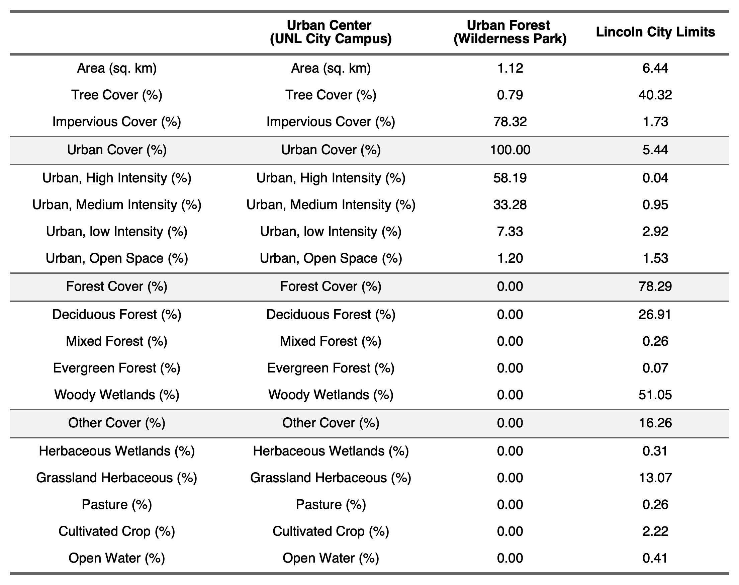

All environmental predictors assessed within a 100-meter radius of the focal web varied by habitat (Table 2). Site tree cover was lower in the urban center than the urban forest with five urban center sites measuring zero tree cover ( $z_{21}$ = -14.50, *P* < 0.001). The urban center sites had higher impervious cover, with all but four sites being zero in the urban forest ( $z_{21}$ = 14.51, *P* < 0.001). The urban center sites also had higher spectral radiance ( $z_{21}$ = 3.08, *P* = 0.002) and artificial light at night radiance ( $z_{21}$ = 22.46, *P* < 0.001). Overall plant species richness was lower in the urban center than the urban forest ( $z_{21}$ = -7.67, *P* < 0.001). Similarly, spiders used a lower diversity of plants as substrates in the urban center (mean ± se = 1.42 ± 0.15 species) than the urban forest (mean ± se = 2.7 ± 0.26 species, $z_{21}$ = -2.08, *P* = 0.037). Site patch area was smaller in the urban center ( $z_{21}$ = -374.2, *P* < 0.001). Road disturbance ( $z_{21}$ = 39.19, *P* < 0.001), highway disturbance ( $z_{21}$ = 9.39, *P* < 0.001), and road length ( $z_{21}$ = -374.2, *P* < 0.001) were higher for urban center sites than sites in the urban forest.

**Table 2** Mean and standard error of environmental predictors collected in 100-meter buffers of each focal web by habitat

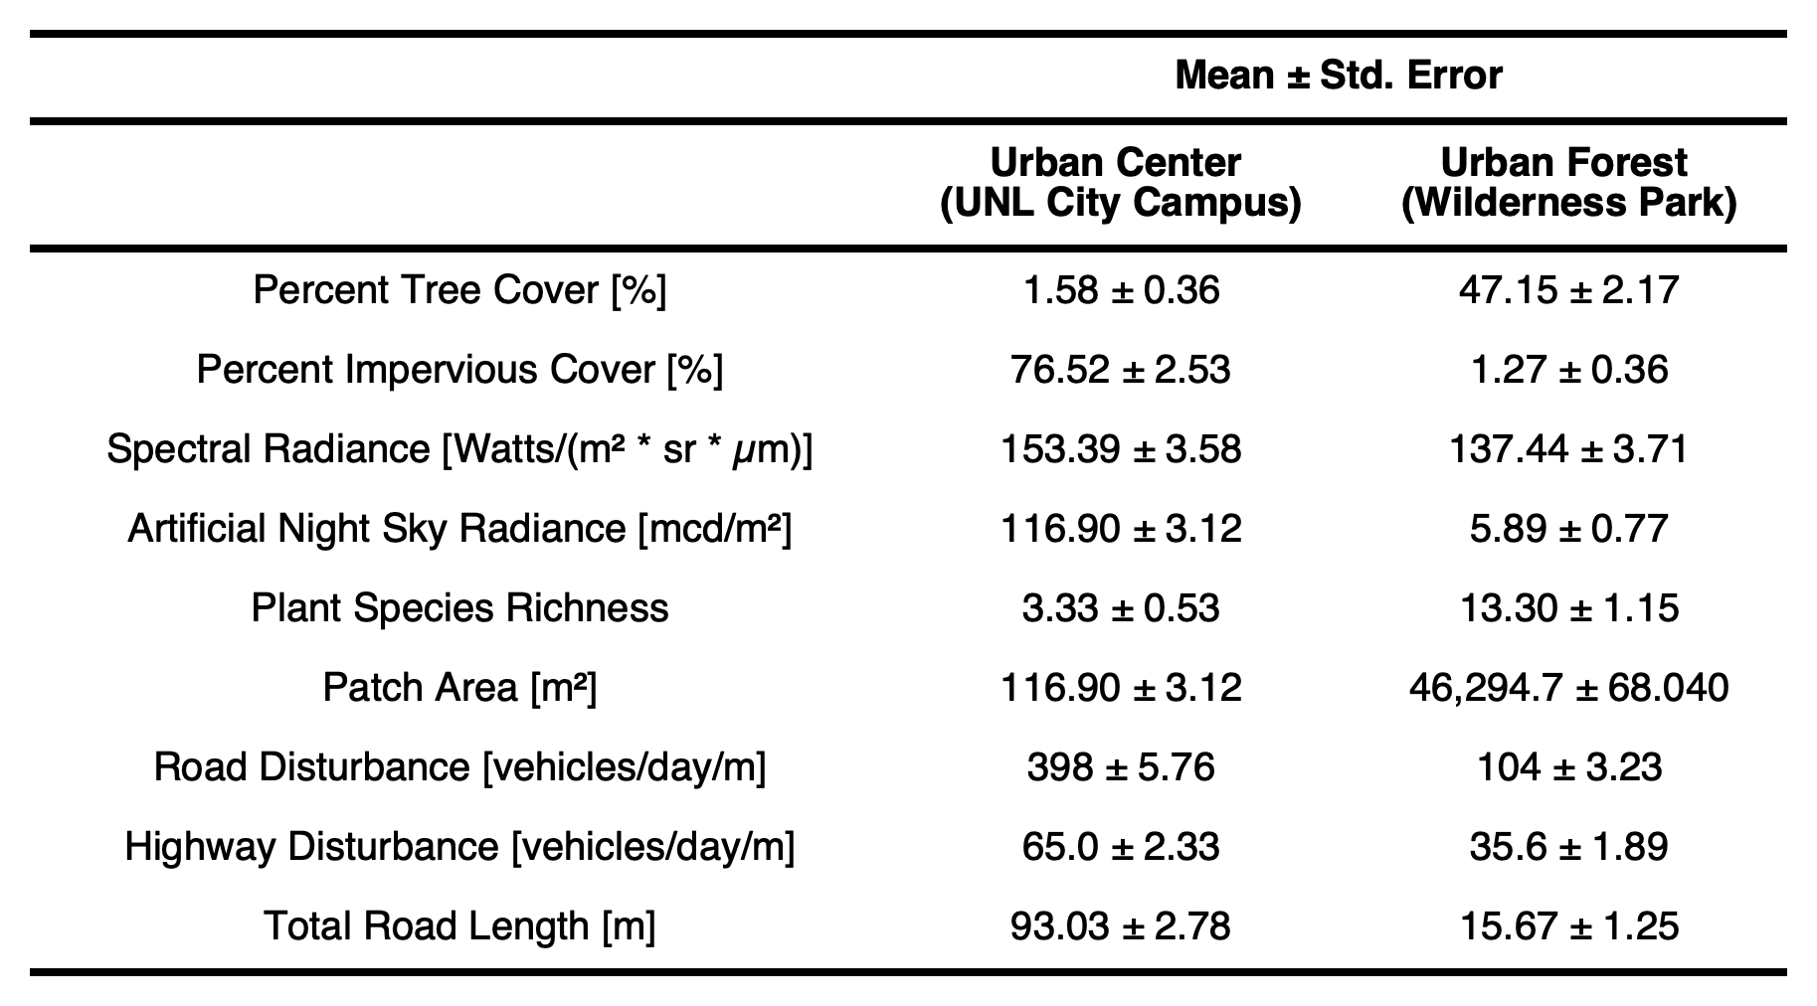

### Web abundance, aggregation, and position between habitats

Over the course of the study, we identified 131 funnel webs as being occupied or unoccupied. Of the 64 occupied webs, 61 were occupied by females indicating that males had likely abandoned their webs in search of females. The 67 unoccupied webs could be those once owned by males or those abandoned by females. While webs were found on many of the same plant types between sites in the urban center and urban forest in varying proportions, 15% of webs in urban center sites were built on non-plant substrates (Fig. S11).

All abundance, aggregation, and position metrics – search distance, the number of webs and spiders within 10 meters of the focal web, the distance from the focal web to the two nearest neighbor webs, and web height – varied by habitat (Fig. 3).

We searched significantly less distance from the start site to the focal web in the urban center than the urban forest ( $z_{20}$ = -10.10, *P* < 0.001, Fig. 3a, Fig. S4). Within a 10-meter radius of the focal web, we counted significantly more webs ( $z_{20}$ = 8.56, *P* < 0.001, Fig. 3b) and spiders ( $z_{20}$ = 4.86, *P* < 0.001, Fig. 3c) in the urban center than the urban forest. We also found that the distances between the focal web and the two nearest neighbors were significantly shorter in the urban center than the urban forest ( $z_{34}$ = -5.60, *P* < 0.001, Fig. 3d). By definition, the second nearest web is further from the focal web than the nearest neighbor ( $z_{34}$ = 14.65, *P* < 0.001). There was a significant interaction between neighbor number and habitat – the second nearest neighbor was significantly further from the focal web than the first nearest neighbor in the urban center, but not the urban forest ( $z_{34}$ = 9.86, *P* < 0.001, Fig. 3d). Lastly, webs were built lower in the urban center than the urban forest ( $z_{128}$ = -2.38, *P* = 0.017, Fig. 3e). This difference was not due to differences in substrate height because we found no difference in substrate height between habitats ( $z_{128}$ = -1.10, *P* = 0.273).

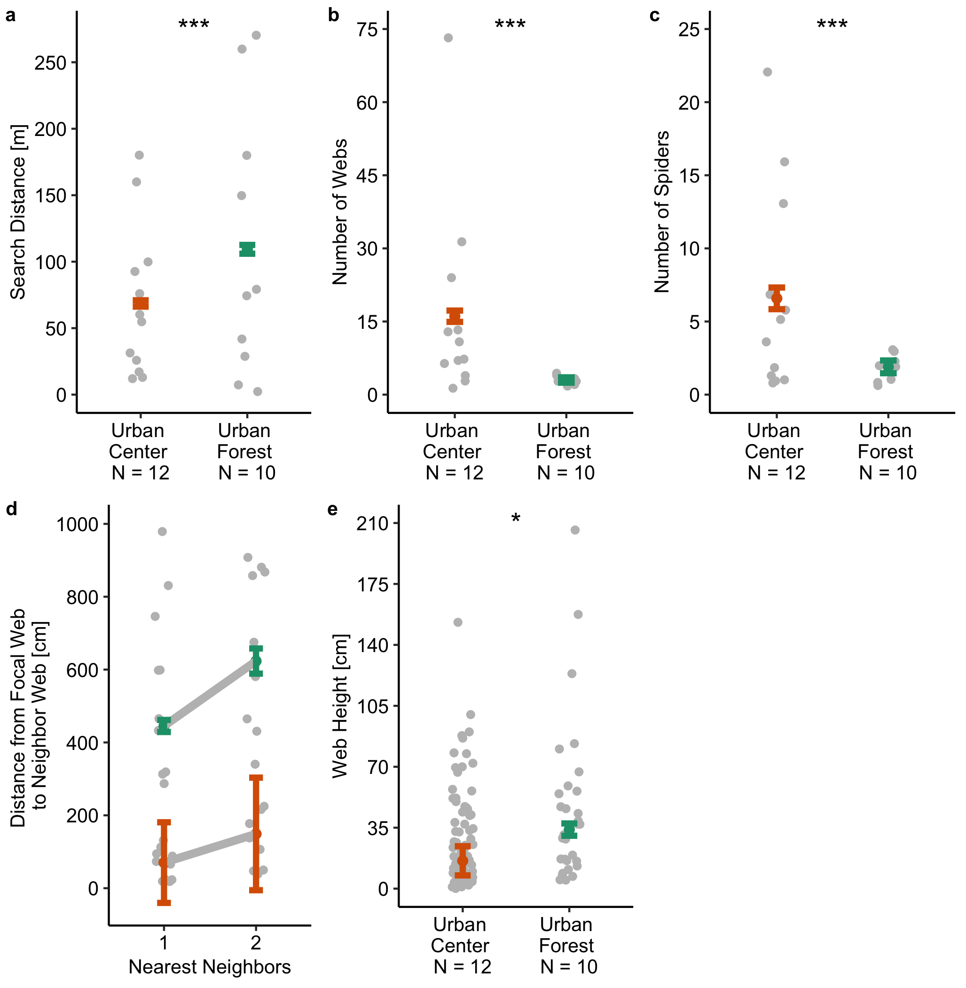

**Fig. 3** Comparison of search distance (a), the number of webs (b) and spiders (c) in a 10-meter radius of the focal web, the distance from the focal web to the first (d) and second (e) nearest neighbors, and web height (f) by habitat - urban forest vs urban center. Grey jittered points represent the raw data while black points and error bars represent the mean and 95% confidence intervals, respectively, from model predictions. Models were either Poisson Generalized Linear Models (a-c) or Poisson Generalized Linear Mixed Effect Models with site as a random factor (d-f). Asterisks indicate significance level (*** *P* < 0.001; ** *P* < 0.01; * *P* < 0.05). We searched shorter distances from the start site to the focal web (a), found more webs (b) and spiders (c) in a 10-meter radius of the focal web, measured shorter distances between the focal web and the two nearest neighbors (d), and recorded shorter web heights (e) in the urban center than the urban forest

We completed a Clark and Evans test (Clark & Evans, 1954) that determines whether aggregation is due to increased density or clumping of individuals. A ratio value significantly below 1 suggests clumping, while values that do not significantly differ from 1 indicate random spacing. We found that webs are aggregated in the urban center (R = 0.47, P < 0.01) and uniform in the urban forest (R = 1.24, P > 0.05). We conclude that aggregations formed for reasons other than increased spider density.

### Environmental predictors of abundance, aggregation, and position

To explore potential environmental factors that might influence our observed variation in spatial patterns, we looked for correlations between response variables (number of webs, number of spiders, nearest neighbor distance, and web height) and environmental predictors overall and within each habitat (Table 3, Table S3, Fig. 4-5).

**Table 3** Results of the top models after AIC model selection from Poisson Generalized Linear Models with the environmental predictors for data overall and subset by habitat (urban center and urban forest). Asterisks indicate significance level (*** *P* < 0.001; ** *P* < 0.01; * *P* < 0.05)

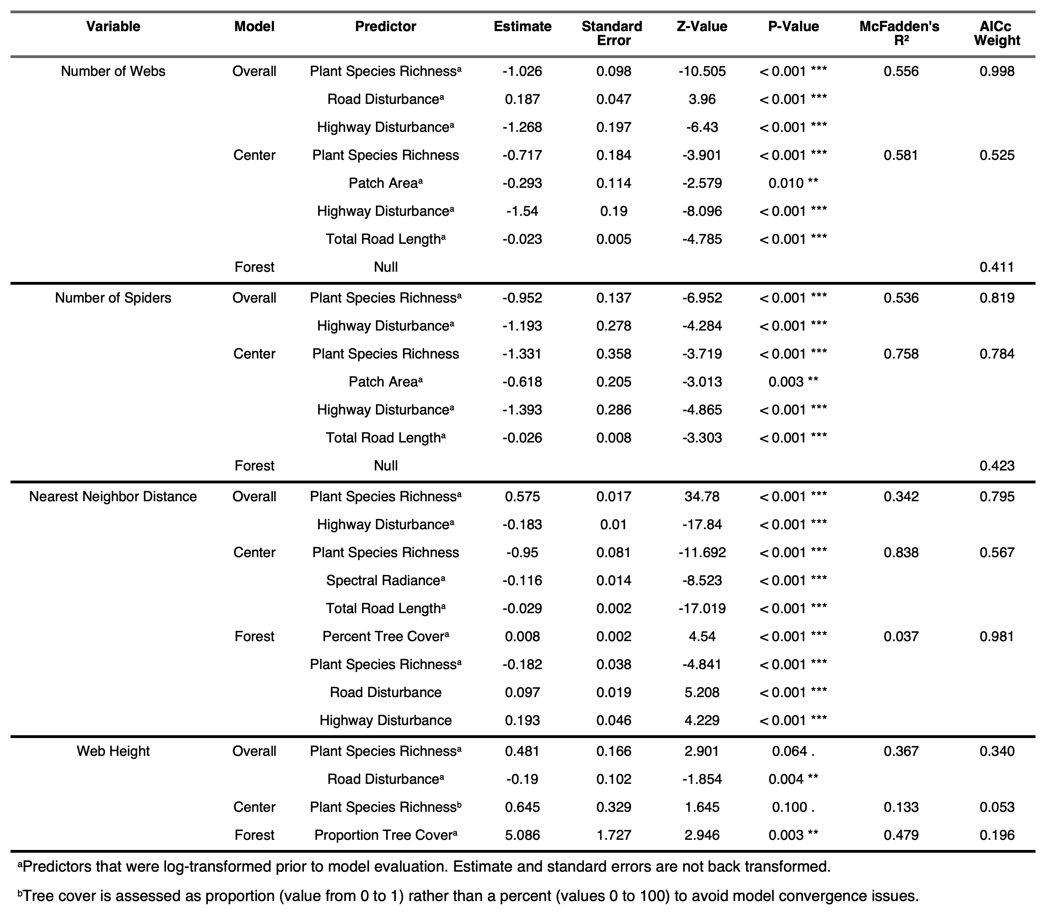

*Abundance* – The top models for the number of webs and the number of spiders yielded similar results (Table 3, Fig. 4). For both measures of abundance, the urban forest subset retained no predictors (Table 3) while the urban center showed a decrease in abundance with increasing plant species richness, patch area, highway disturbance, and road length (Table 3, Fig. 4). The model average for the number of webs subset by urban center suggested similar results (Table S3). Plant species richness and highway disturbance both had a negative relationship with abundance measures for the overall data set (Table 3, Fig. S12). Interestingly, the top model of web abundance retained road disturbance and suggested a positive relationship overall (Table 3, Fig. S12).

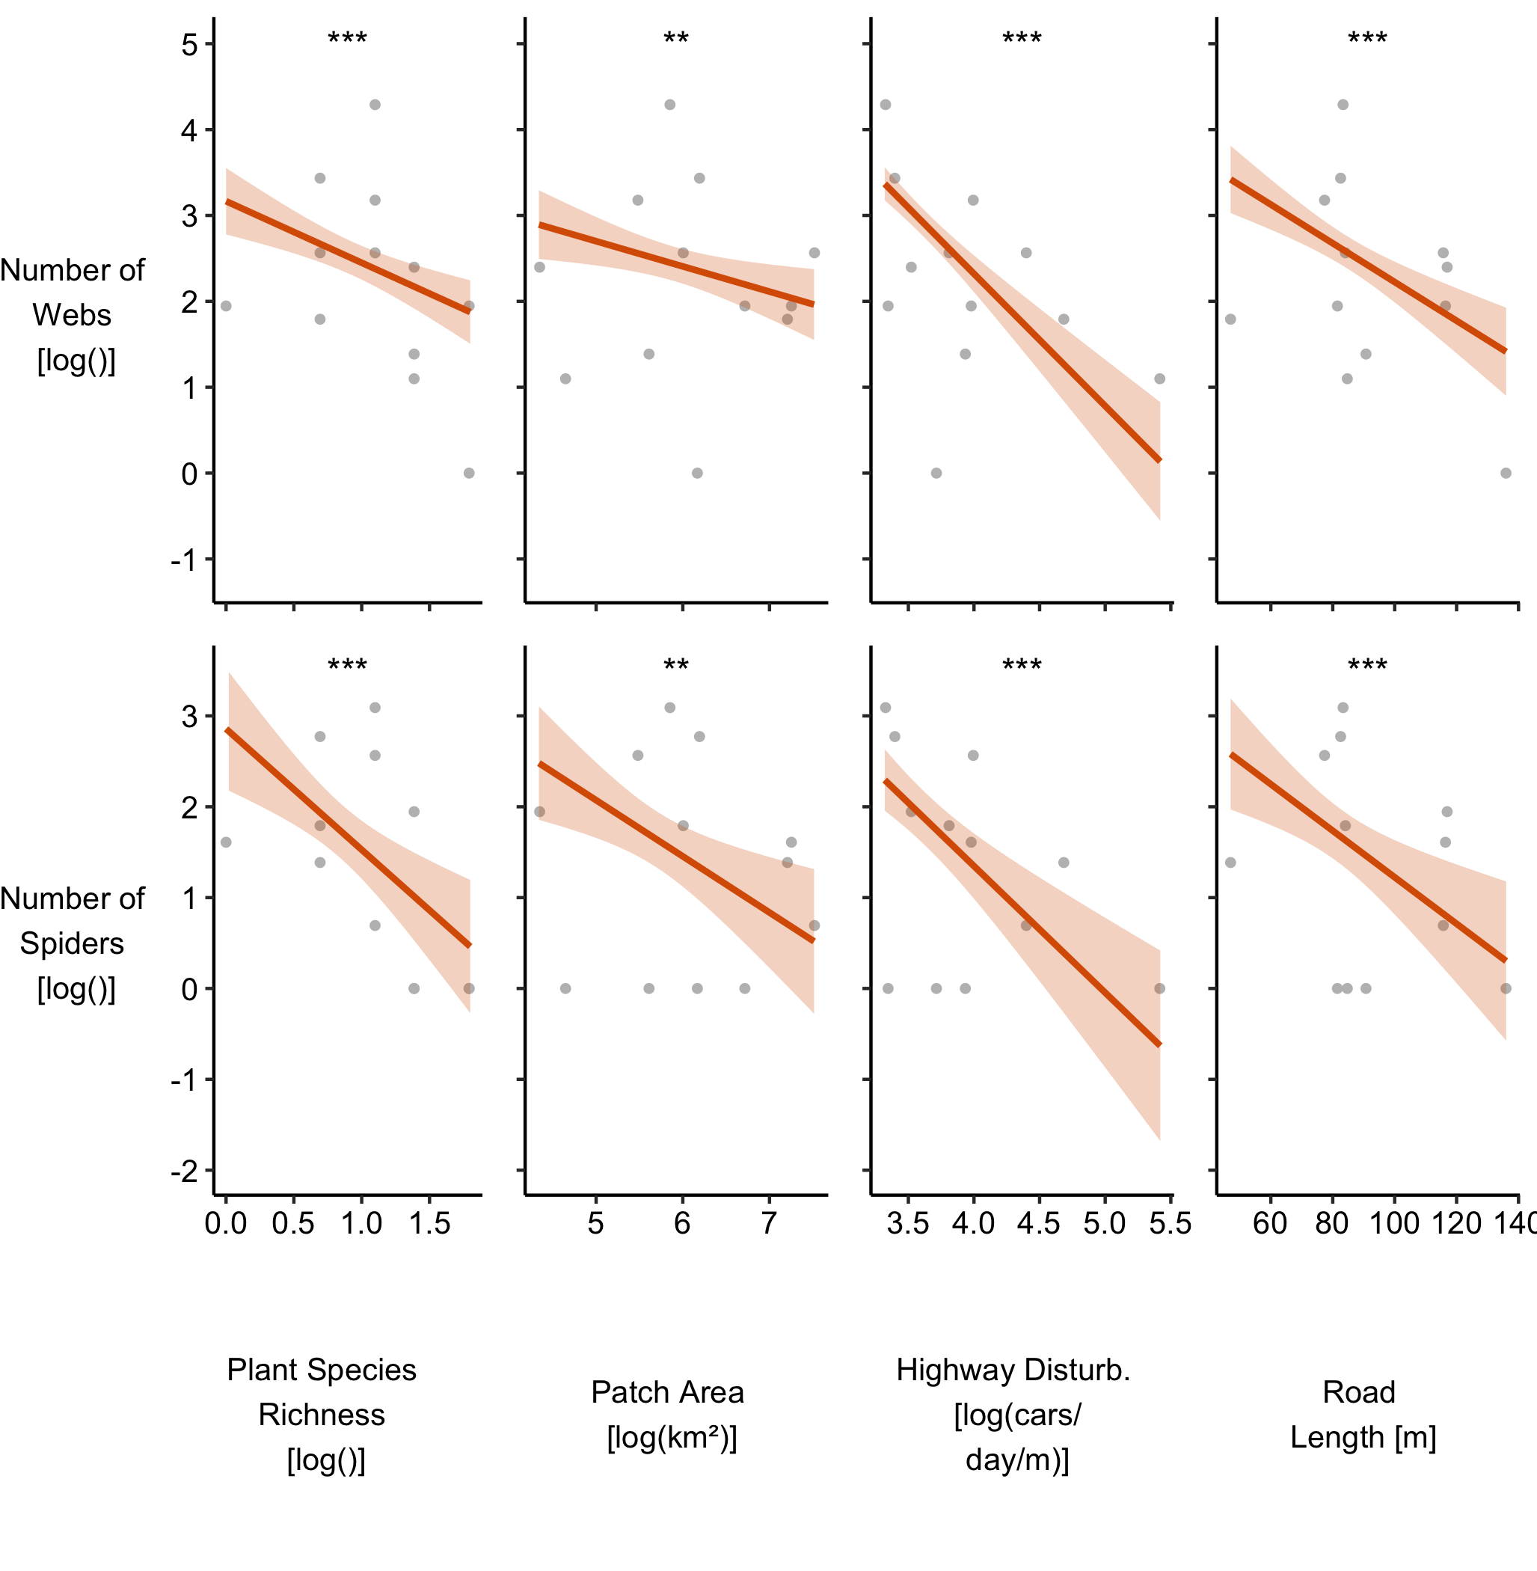

**Fig. 4** Significant correlations between measures of abundance (number of webs and spiders) and the environmental predictors for the urban center subset. Spectral radiance and road disturbance were dropped from both models of abundance for the urban center subset after AIC model selection. All environmental predictors of abundance were dropped from the urban forest subset. The regression lines and shaded regions represent the predictions and 95% confidence intervals (respectively) from the top Poisson Generalized Linear Model after AIC selection. The points represent the raw data. Asterisks indicate significance level (*** *P* < 0.001; ** *P* < 0.01; * *P* < 0.05)

*Aggregation* – Spiders were closer together across habitats when plant species richness was low and when road disturbance was high (Table 3, Fig. S12). In the urban forest subset, less tree cover, lower road and highway disturbance, and greater plant species richness were associated with nearness (Table 3, Fig. 5), however, this model was a poor fit ( $R^{2}$ = 0.037). Urban center spiders were more aggregated where plant species richness, spectral radiance, and road length are high (Table 3, Fig. 5). The relationship between nearest neighbor distance and plant species richness is opposite when analyzed across habitats and within the urban subset. This is likely do to the differences in plant species richness and aggregation between habitats – the urban center had low neighbor distance and plant diversity while the urban forest had high neighbor distance and plant diversity. The model average for the nearest neighbor distance in the urban center corroborates the findings of the top model and adds that webs were clumped when patch area was larger (Table S3).

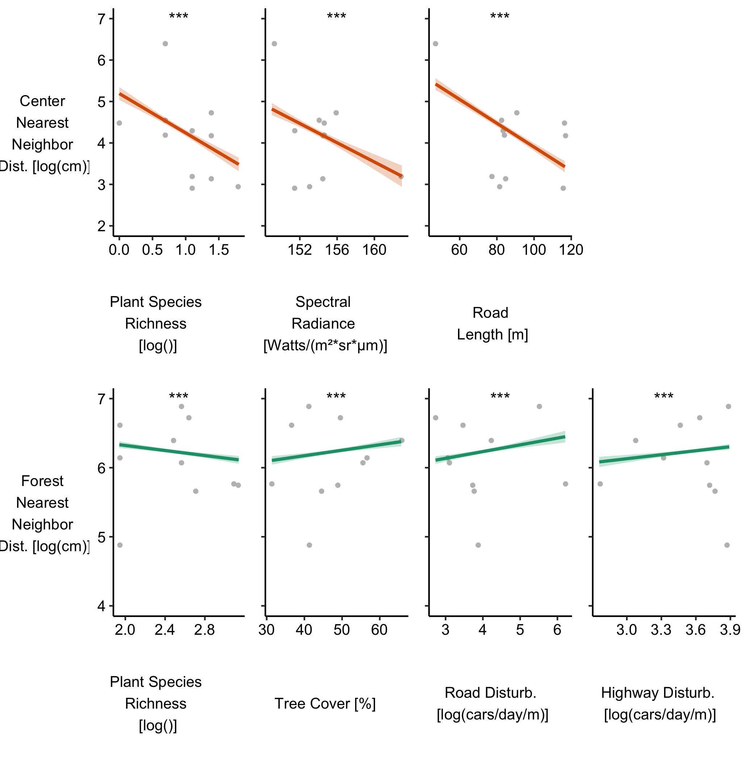

**Fig. 5** Significant correlations between the aggregation measure (nearest neighbor distance) and the environmental predictors for the urban center subset (plant species richness, spectral radiance, and total road length) and the urban forest subset (plant species richness, tree cover, and road and highway disturbance). All other environmental predictors were dropped from models of nearest neighbor distance after AIC model selection. The regression lines and shaded regions represent the predictions and 95% confidence intervals (respectively) from the top Poisson Generalized Linear Model after AIC selection. The points represent the raw data. Asterisks indicate significance level (*** *P* < 0.001; ** *P* < 0.01; * *P* < 0.05)

*Web Height* – Webs were built higher overall when the number of plant species is higher (Table 3, Fig. S12). A trend also suggests that lower webs were associated with higher road disturbance, although this result is not significant (Table 3, Fig. S12). In the urban forest, web height is positively related to tree cover (Table 3). While plant species richness was included in the top model, it did not vary by web height in the urban center (Table 3). We see similar results from the model averages for web height (Table S3). Despite the addition of predictors under the model averages, none of the added predictors varied by web height in their respective data sets (Table S3).

For statistical analysis and figures of response variables by land cover class, see supplemental material (Table S2, Fig. S10). Following Likelihood Ratio tests, we find that all response variables significantly vary by land cover class (Table S2). There was no difference in search distance between urban medium-intensity, urban low-intensity, and deciduous forest. However, we searched significantly shorter in urban high-intensity and significantly further in woody wetlands (Fig. S10a). The number of webs and spiders only varied by habitat - urban low-, medium-, and high-intensity had more webs and spiders than deciduous forest or woody wetlands (Fig. S10b-c). For the urban intensities, web distance was shortest at low intensities and furthest at medium intensities with high urban intensity suggest web height between low and medium intensities (Fig. S10d). Nearest neighbor distance was shorter for woody wetlands than deciduous forest (Fig. S10d). Lastly, web height showed no difference between land cover class with pairwise comparisons (Fig. S10e).

## Discussion

The two urban habitats that we studied here – an urban forest and an urban center – significantly differed by the selected environmental conditions. The urban forest sites had higher tree cover, plant diversity, and patch area. On the other hand, the urban center exhibited higher impervious cover, light at night, surface temperature, road and highway disturbance, and total road length. These urban habitats each host *Agelenopsis pennsylvanica*, but the spatial patterns displayed by this funnel-weaving spider vary considerably. The spiders are more abundant, aggregated, and build lower webs in the urban center. We hypothesized that many of the environmental conditions that are distinct between the habitats may also be influencing such differences. We found that spatial patterns were often retlated to plant species richness and disturbance from road and highway traffic.

### Spiders are more abundant and aggregated with lower webs in the urban center

Both webs and spiders of *A. pennsylvanica* were more abundant and aggregated in the urban center than the urban forest. Shorter search distances to the focal web corroborates this finding, as previous studies have used search distance as an estimate of abundance Kral et al. (2018).

Higher abundance of animals in urban habitats may reflect a higher tolerance of urban conditions and disturbances. Tolerance of urban ecosystems is dependent on the ecology and behavior of the organism, such as being a generalist consumer (Bang & Faeth, 2011a; Sol et al., 2013), and the scale of the measurements being collected (Lowe et al., 2018; Philpott et al., 2014), resulting in conflicting findings in the literature. We have observed *A pennsylvanica* attacking a wide variety of arthropod prey with no evidence of specialization of a particular type (personal observations). Thus, we suggest that *A. pennsylvanica* is a generalist predator. While arthropods are generally found to decline in urban environments (Piano et al., 2020; Wagner, 2020), generalists are more likely to be urban exploiters than specialists (Callaghan et al., 2021). For example, *Nephila plumipes*, a generalist predator, was found to abundantly occupy urban habitats where prey abundance supported greater numbers of spiders (Lowe et al., 2016).

Prey abundance has been repeatedly found to be a strong predictor of spider abundance Harwood et al. (2001). Although we might hypothesize higher prey availability in the urban forest, we observed far greater potential for competition from other spider species in the urban forest than the urban center. In the urban center, *A. pennsylvanica* appear to dominate spider communities. Prey abundance, then, may play a role in our observed differences in spider abundance between the urban center and the urban forest.

Multiple reports have found spider aggregations in urban habitats (Mammola et al., 2018; Trubl et al., 2012), another spatial measure that is often related directly or indirectly to the abundance of prey. Territoriality, especially over prey resources, often drives regular (and non-random) spacing of solitary species (Riechert, 1974a), but aggregations can form when abundant resources allow for increased tolerance of neighbors (Gillespie, 1987). Light at night in cities attracts insects creating pockets of increased prey abundance for spiders that may lead to spiders aggregating under such light sources (Davies et al., 2012). Although we did not measure microhabitat levels of light at night or prey abundance, *A. pennsylvanica* were more aggregated in the urban center where light at night radiance was higher than the urban forest. Thus, future research should test the impact of prey abundance and competition on spider abundance and aggregation in urban habitats.

We also found that the webs of urban center spiders were built lower than webs in the urban forest, and this result was independent of the height of the substrate. Webs may vary in height based on the type of prey being ensnared. We have observed *Agelenopsis* spiders capture flying, hopping, and crawling insects. Arthropod community structure can be highly variable between urban habitats (Bang & Faeth, 2011b), and urban centers and urban forests may support different types of prey items for *A. pennsylvanica*. Lower webs in the urban center may be ideal for more crawling prey while higher webs in the urban forest may better trap flying insects. Alternatively, webs in different habitats may experience different levels of disturbance. In the urban center where lawns are mowed frequently and ornamental plants are regularly pruned, spiders could maintain lower webs to conserve energy from frequent rebuilding.

Additionally, urban forests likely support (and act as a refuge for) many ground dwelling vertebrates, whose movement along the forest floor could frequently damage lower webs. Greater tree coverage in the urban forest predicted higher webs, which may further suggest that small mammal movement could destroy low webs as areas with greater tree cover may provide protection and food resources for small mammals (Sarkar & Bhadra, 2022). Future research should assess prey type available and small animal abundance and movement between these two habitats. We speculate that vibratory noise may promote lower web heights based on a trend that showed lower web heights overall at sites with higher road disturbance. Perhaps vibratory noise is dampened on a plant nearer to the ground, but this idea requires further testing.

### Several environmental predictors relate to spatial patterns

We found that webs and spiders were more abundant (in the urban center) and more aggregated as plant species richness decreased. The urban center sites were covered in grass lawns and managed landscaping that usually had few plant species present, but in high abundance. Sites with lower plant diversity may have few plant species that are highly preferred, leading to higher spider abundance. Research has shown mixed but often positive effects of plant diversity on spider abundance (Koricheva et al., 2000; Malumbres-Olarte et al., 2013), suggesting that plant community composition may play a vital, yet context-specific role. To better understand the role that plant species play in abundance would require comparing plant communities between patches used by spiders versus those devoid of spiders. We speculate that greater aggregation on more diverse plant communities may suggest that *A. pennsylvanica* prefers a certain plant or type of plant, especially in the urban center where we observed similar plants clumped in space.

We found further support for the importance of plant life as urban forest spiders were more aggregated at sites with less tree cover. A study that measured invertebrate abundance after manipulating tree cover found that newly formed tree gaps have greater vegetation height and coverage and increased soil moisture and temperature, all of which led to an overall increase in invertebrate abundance (Perry et al., 2018). Similar results have been found with spider communities in particular (Černecká et al., 2020). Since spider aggregations tend to occur where prey abundance is higher, we might predict that lower tree cover indirectly increases spider aggregation through an increase in prey abundance.

Disturbance from roads and highways also seemed to play a role in spider spatial patterns. We show that webs and spiders are more abundant in urban center sites that had lower highway disturbance. Living in close proximity to high-traffic roads is likely to affect the vibratory environment that the spider is exposed to. *Agelenopsis pennsylvanica* rely heavily on vibrations to capture prey (Riechert & Maupin, 1998), court potential mates (Singer et al., 2000), and potentially evade predators (Riechert & Hedrick, 1990). Thus, we suspect that vibratory noise may impact web site selection, choosing sites that mitigate these effects. Also, selective spiders in urban habitats may choose plants as web substrates that reduce vibratory noise since different plants transmit vibrations differently (Cocroft et al., 2006). Although most research on the effects of noise on arthropod behavior has focused on acoustic rather than vibratory noise (Roberts & Howard, 2022), some studies have found strong negative effects of acoustic and vibratory noise on arthropod behavior (Jessie. P. Bunkley et al., 2017; Carosi et al., 2019). A recent study shows that the orb-weaving spider, *Larinioides sclopetarius* is able to detect airborne sound that induces vibrations in the web (Zhou et al., 2022).

Lower road and highway disturbance was associated with larger spider aggregations in the urban forest, but had no effect on urban center spiders. Perhaps noise negatively affects urban forest spiders – encouraging spiders to inhabit areas further from noise sources and reducing space between neighbors. Many spiders are thought to be plastic in the structure and tuning of their webs (Blamires, 2010; Mortimer et al., 2016), and urban exploiters are often fast to adjust to changing conditions (Kralj-Fišer et al., 2017), so spiders reared in or descended from spiders in the urban center might be better able to tune their webs to decrease vibrations, although this hypothesis requires further testing. It will also be important to differentiate whether these differences in behavior between environments is based on developmental exposure, behavioral plasticity, or genetic differentiation.

More road length in the 100-meter radius resulted in fewer but more aggregated urban center webs and spiders. Total road length could be another indirect measure of vibratory noise and/or represent dispersal barriers. High traffic roads may increase mortality of dispersing spiders via collisions with vehicles, or passing cars may influence wind currents making aerial dispersal difficult (Martin et al., 2019). Higher spider abundance in smaller patches may be more evidence for the role of environmental barriers. Furthermore, small patch areas may be a preferred habitat of edge specialists (Martinson & Fagan, 2014), as we suspect *A. pennsylvanica* may be.

We note that urban forest web and spider abundance did not correlate with any of the selected environmental conditions, potentially due to low variation. For example, only two to four webs and one to three spiders were found per site in the urban forest compared to one to 73 webs and one to 22 spiders in the urban center. Alternatively, urban forest abundance may be better predicted by factors not assessed here, such as prey and predator abundance or dispersal limitation (Bonte et al., 2003; Harwood et al., 2001).

Lastly, spiders in the urban center were more aggregated at sites with higher spectral radiance (a measure of surface temperature). Urban centers tend to be warmer on average compared to surrounding areas due to heat trapping via pavement in a phenomenon called the Urban Heat Island Effect (J. C. Johnson et al., 2020). Aggregation formation in warmer sites could be the result of preference for or acclimation to warmer areas (Meineke et al., 2013) or perhaps aggregation occurs at limited thermal refuges (Riechert, 1974a). We have shown that human-caused environmental changes correlate with spider spatial patterns, but there are likely many other forms of human disturbance than those tested here.

## Conclusions

Our study shows that a solitary, generalist predator is more abundant and aggregated with lower web height in an urban center compared to an urban forest – habitats that vary significantly in environmental conditions. We did not measure community-level interactions among organisms, such as the effects of prey abundance. However, correlations between spatial pattern and environmental condition indirectly indicate that such interspecific interactions may be essential for monitoring spider aggregations. Spider aggregations in urban centers can have medical consequences, such as dense *Lactrodectus hesperus* aggregations (A. Johnson et al., 2011), and aesthetic concerns, as is the case with aggregations of *Brigittea civica* under archways of historic buildings (Mammola et al., 2018). On the other hand, spider aggregations could control pest outbreaks that threaten human health and food supply. We emphasize that elucidating the complex relationship between the arthropod abundance and the impacts of urbanization is essential for our understanding of how urbanization affects ecosystem services and food web interactions. Our variables that estimate the potential for vibratory noise negatively affected spider abundance while promoting lower web heights, potentially to reduce interference from vibratory noise. Noise variables had opposite effects on aggregative behavior of spiders in the different habitats that may indicate differences in tolerance to noise, but more research is necessary to test this hypothesis. Thus, urban habitats can vary in environmental conditions which can determine how animals distribute themselves in space and affect predator-prey interactions.

## References

Alberti, M., Palkovacs, E. P., Roches, S. D., Meester, L. D., Brans, K. I., Govaert, L., Grimm, N. B., Harris, N. C., Hendry, A. P., Schell, C. J., Szulkin, M., Munshi-South, J., Urban, M. C., & Verrelli, B. C. (2020). The complexity of urban eco-evolutionary dynamics. *BioScience*, *70*(9), 772–793. <https://doi.org/10.1093/biosci/biaa079>

Amundrud, S. L., Videla, M., & Srivastava, D. S. (2018). Dispersal barriers and climate determine the geographic distribution of the helicopter damselfly mecistogaster modesta. *Freshwater Biology*, *63*(2), 214–223. <https://doi.org/10.1111/fwb.13054>

Anderson, R. P. (2017). When and how should biotic interactions be considered in models of species niches and distributions. *Journal of Biogeography*, *44*(1), 8–17. <https://doi.org/10.1111/jbi.12825>

Bang, C., & Faeth, S. H. (2011b). Variation in arthropod communities in response to urbanization: Seven years of arthropod monitoring in a desert city. *Landscape and Urban Planning*, *103*(3-4), 383–399.

Bang, C., & Faeth, S. H. (2011a). Variation in arthropod communities in response to urbanization: Seven years of arthropod monitoring in a desert city. *Landscape and Urban Planning*, *103*(3-4), 383–399.

Barber, J. R., Crooks, K. R., & Fristrup, K. M. (2010). The costs of chronic noise exposure for terrestrial organisms. *Trends in Ecology and Evolution*, *25*(3), 180–189. <https://doi.org/10.1016/j.tree.2009.08.002>

Bartoń, K. (2020). *MuMIn: Multi-model inference*. <https://CRAN.R-project.org/package=MuMIn>

Bates, D., Mächler, M., Bolker, B., & Walker, S. (2015). Fitting linear mixed-effects models using lme4. *Journal of Statistical Software*, *67*(1), 1–48. <https://doi.org/10.18637/jss.v067.i01>

Bennett, A. B., & Lovell, S. T. (2014). A comparison of arthropod abundance and arthropodmediated predation services in urban green spaces. *Insect Conservation and Diversity*, *7*(1), 405–412.

Blamires, S. J. (2010). Plasticity in extended phenotypes: Orb web architectural responses to variations in prey parameters. *Journal of Experimental Biology*, *213*(18), 3207–3212.

Bolker, B., & Robinson, D. (2022). *Broom.mixed: Tidying methods for mixed models*. <https://CRAN.R-project.org/package=broom.mixed>

Bonte, D., Vandenbroecke, N., Lens, L., & Maelfait, J.-P. (2003). Low propensity for aerial dispersal in specialist spiders from fragmented landscapes. *Proceedings of the Royal Society of London. Series B: Biological Sciences*, *270*(1524), 1601–1607.

Boulangeat, I., Gravel, D., & Thuiller, W. (2012). Accounting for dispersal and biotic interactions to disentangle the drivers of species distributions and their abundances. *Ecology Letters*, *15*, 584–593. <https://doi.org/10.1111/j.1461-0248.2012.01772.x>

Bradley, C. A., & Altizer, S. (2007). Urbanization and the ecology of wildlife. *Trends in Ecology and Evolution*, *22*(2), 95–102. <https://doi.org/10.1016/j.tree.2006.11.001>

Buckland, S. T., Anderson, D. R., Burnham, K. P., & Laake, J. L. (2005). Distance sampling. In *Encyclopedia of biostatistics*. John Wiley & Sons, Ltd. https://doi.org/<https://doi.org/10.1002/0470011815.b2a16019>

Bunkley, J. P., McClure, C. J. W., Kawahara, A. Y., Francis, C. D., & Barber, J. R. (2017). Anthropogenic noise changes arthropod abundances. *Ecology and Evolution*, *7*(1), 2977–2985.

Bunkley, Jessie. P., McClure, C. J. W., Kawahara, A. Y., Francis, C. D., & Barber, J. R. (2017). Anthropogenic noise changes arthropod abundances. *Ecology and Evolution*, *7*(9), 2977–2985. <https://doi.org/10.1002/ece3.2698>

Cadenasso, M. L., Pickett, S. T. A., & Schwarz, K. (2007). Spatial heterogeneity in urban ecosystems: Reconceptualizing land cover and a framework for classification. *Frontiers in Ecology and the Environment*, *5*(2), 80–88. <https://doi.org/10.1890/1540-9295(2007)5[80:SHIUER]2.0.CO;2>

Callaghan, C. T., Bowler, D. E., & Pereira, H. M. (2021). Thermal flexibility and a generalist life history promote urban affinity in butterflies. *Global Change Biology*, *27*(15), 3532–3546.

Carosi, V., Guerra, V., Furtado, R., Lucia, D., Miron, L. R., Borges-Martins, M., Both, C., & Narins, S. W. F. A. M., Peter M. And Meenderink. (2019). Anthropogenic substrate-borne vibrations impact anuran calling. *Scientific Reports*, *9*, 19456. <https://doi.org/10.1038/s41598-019-55639-0>

Černecká, L., Mihál, I., Gajdoš, P., & Jarčuška, B. (2020). The effect of canopy openness of european beech (fagus sylvatica) forests on ground-dwelling spider communities. *Insect Conservation and Diversity*, *13*(3), 250–261.

Chan, E. K., Zhang, Y., & Dudgeon, D. (2009). Substrate availability may be more important than aquatic insect abundance in the distribution of riparian orb-web spiders in the tropics. *Biotropica*, *41*(2), 196–201.

Chase, J. M., & Leibold, M. A. (2003). *Ecological niches: Linking classical contemporary approaches*. University of Chicago Press.

Churchill, E. R., Bridle, J. R., & Thom, M. D. F. (2020). Spatially clustered resources increase male aggregation and mating duration in drosophila melanogaster. *Animal Behaviour*, *169*, 45–50. <https://doi.org/10.1016/j.anbehav.2020.09.002>

City of Lincoln Transportation & Utilities. (2021). *Average daily traffic volume*. <https://www.lincoln.ne.gov/City/Departments/LTU/Transportation/Traffic-Engineering/Average-Daily-Traffic-Volume>

Clark, P. J., & Evans, F. C. (1954). Distance to nearest neighbor as a measure of spatial relationships in populations. *Ecology*, *35*(4), 445–453.

Cobbold, S. M., & Supp, S. R. (2012). Patch shape alters spider community structure: Links between microhabitat choice and sensitivity to increased edge habitat. *Journal of Insect Conservation*, *16*(1), 581–589.

Cocroft, R., Shugart, H., Konrad, K., & Tibbs, K. (2006). Variation in plant substrates and its consequences for insect vibrational communication. *Ethology*, *112*(8), 779–789.

Dahirel, M., Dierick, J., De Cock, M., & Bonte, D. (2017). Intraspecific variation shapes community-level behavioral responses to urbanization in spiders. *Ecology*, *98*(9), 2379–2390. <https://doi.org/10.1002/ecy.1915>

Dale, A. G., & Frank, S. D. (2018). Urban plants and climate drive unique arthropodinteractions with unpredictable consequences. *Current Opinion in Insect Science*, *29*(1), 27–33.

Davies, T. W., Bennie, J., & Gaston, K. J. (2012). Street lighting changes the composition of invertebrate communities. *Biology Letters*, *8*(5), 764–767.

Diez, J. M., & Pulliam, R. (2007). Hierarchical analysis of species distributions and abundance across environmental gradients. *Ecology*, *88*(12), 3144–3152. <https://doi.org/10.1890/07-0047.1>

Dooley, J. M., & Brown, M. T. (2020). The quantitative relation between ambient soundscapes and landscape development intensity in north central florida. *Landscape Ecology*, *35*, 113–127. <https://doi.org/10.1007/s10980-019-00936-2>

Fenoglio, M. S., Rossetti, M. R., & Videla, M. (2020). Negative effects of urbanization on terrestrial arthropod communities: A meta-analysis. *Global Ecology and Biogeography*, *29*(8), 1412–1429.

Fox, J., & Weisberg, S. (2019). *An R companion to applied regression* (Third). Sage. <https://socialsciences.mcmaster.ca/jfox/Books/Companion/>

Gillespie, R. G. (1987). The role of prey availability in aggregative behaviour of the orb weaving spider tetragnatha elongata. *Animal Behaviour*, *35*(3), 675–681.

Gippet, J. M. W., Mondy, N., Diallo-Dudek, J., Bellec, A., Dumet, A., Mistler, L., & Kaufmann, B. (2017). I’m not like everybody else: Urbanization factors shaping spatial distribution of native and invasive ants are species-specific. *Urban Ecosystems*, *20*(1), 157–169.

Gohel, D., & Skintzos, P. (2022). *Flextable: Functions for tabular reporting*.

Gomes, D. G., Hesselberg, T., & Barber, J. R. (2020). Phantom river noise alters orb-weaving spider abundance, web size, and prey capture. *Functional Ecology*, *35*, 717–726.

Grimm, N. B., Foster, D., Groffman, P., Grove, J. M., & Hopkinson, C. S. (2008). The changing landscape: Ecosystem responses to urbanization and pollution across climatic and societal gradients. *Frontiers in Ecology and the Environment*, *6*(5), 264–272. <https://doi.org/10.1890/070147>

Guarisco, H. (2014). The funnelweb spider genus agelenopsis (araneae: Agelenidae) in kansas. *Transactions of the Kansas Academy of Science (1903-)*, *117*(1/2), 79–87. <https://www.jstor.org/stable/24887722>

Guenard, B., Cardinal-De Casas, A., & Dunn, R. R. (2015). High diversity in an urban habitat: Are some animal assemblages resilient to long-term anthropogenic change? *Urban Ecosystems*, *18*, 449–463.

Harwood, J., Sunderland, K., & Symondson, W. (2001). Living where the food is: Web location by linyphiid spiders in relation to prey availability in winter wheat. *Journal of Applied Ecology*, *38*(1), 88–99.

Hopkins, G. R., Gaston, K. J., Visser, M. E., Elgar, M. A., & Jones, T. M. (2018). Artificial light at night as a driver of evolution across urban-rural landscapes. *Frontiers in Ecology and the Environment*, *16*(8), 472–479. <https://doi.org/10.1002/fee.1828>

Hothorn, T., Bretz, F., & Westfall, P. (2008). Simultaneous inference in general parametric models. *Biometrical Journal*, *50*(3), 346–363.

Ivers, N. A., Jordan, Z., Cohen, H., Tripodi, A., Brown, M. J. F., Liere, H., Lin, B. B., Philpott, S., & Jha, S. (2022). Parasitism of urban bumble bees influenced by pollinator taxonomic richness, local garden management, and surroundings impervious cover. *Urban Ecosystems*. <https://doi.org/10.1007/s11252-022-01211-0>

Johnson, A., Revis, O., & Johnson, J. C. (2011). Chemical prey cues influence the urban microhabitat preferences of western black widow spiders, latrodectus hesperus. *The Journal of Arachnology*, *39*(3), 449–453.

Johnson, J. C., Garver, E., & Martin, T. (2020). Black widows on an urban heat island: Extreme heat affects spider development and behaviour from egg to adulthood. *Animal Behaviour*, *167*, 77–84.

Johnson, J. C., Trubl, P. J., & Miles, L. S. (2012). Black widows in an urban desert: City-living compromises spider fecundity and egg investment despite urban prey abundance. *The American Midland Naturalist*, *168*(2), 333–340.

Johnson, M. T. J., & Munshi-South, J. (2017). Evolution of life in urban environments. *Science*, *358*, 607. <https://doi.org/10.1126/science.aam8327>

Kassambara, A. (2020). *Ggpubr: ’ggplot2’ based publication ready plots*. <https://CRAN.R-project.org/package=ggpubr>

Koricheva, J., Mulder, C. P., Schmid, B., Joshi, J., & Huss-Danell, K. (2000). Numerical responses of different trophic groups of invertebrates to manipulations of plant diversity in grasslands. *Oecologia*, *125*(2), 271–282.

Kotze, J., Venn, S., Niemelä, J., & Spence, J. (2011). Effects of urbanization on the ecology and evolution of arthropods. *Urban Ecology, Patterns, Processes and Applications. Oxford University Press, New York*, 159–166.

Kral, K., Harmon, J., Limb, R., & Hovick, T. (2018). Improving our science: The evolution of butterfly sampling and surveying methods over time. *Journal of Insect Conservation*, *22*(1), 1–14.

Kralj-Fišer, S., Hebets, E. A., & Kuntner, M. (2017). Different patterns of behavioral variation across and within species of spiders with differing degrees of urbanization. *Behavioral Ecology and Sociobiology*, *71*(8), 1–15.

Kuhn, M. (2022). *Caret: Classification and regression training*. <https://CRAN.R-project.org/package=caret>

Lenth, R. V. (2022). *Emmeans: Estimated marginal means, aka least-squares means*. <https://CRAN.R-project.org/package=emmeans>

Lowe, E., Threlfall, C., Wilder, S., & Hochuli, D. (2018). Environmental drivers of spider community composition at multiple scales along an urban gradient. *Biodiversity and Conservation*, *27*(4), 829–852.

Lowe, E., Wilder, S., & Hochuli, D. (2016). Persistence and survival of the spider nephila plumipes in cities: Do increased prey resources drive the success of an urban exploiter? *Urban Ecosystems*, *19*(2), 705–720.

Malumbres-Olarte, J., Vink, C. J., Ross, J. G., Cruickshank, R. H., & Paterson, A. M. (2013). The role of habitat complexity on spider communities in native alpine grasslands of new zealand. *Insect Conservation and Diversity*, *6*(2), 124–134.

Mammola, S., Isaia, M., Demonte, D., Triolo, P., & Nervo, M. (2018). Artificial lighting triggers the presence of urban spiders and their webs on historical buildings. *Landscape and Urban Planning*, *180*, 187–194.

Martin, A. E., Pervin, E., Graham, S., Henry, M., & Fahrig, L. (2019). Abundance of aerially-dispersing spiders declines with increasing road traffic. *Ecoscience*, *26*(4), 383–388.

Martinson, H. M., & Fagan, W. F. (2014). Trophic disruption: A meta-analysis of how habitat fragmentation affects resource consumption in terrestrial arthropod systems. *Ecology Letters*, *17*(9), 1178–1189.

McDonnell, M. J., & Pickett, S. T. A. (1990). Ecosystem structure and function along urban-rural gradients: An unexploited opportunity for ecology. *Ecology*, *71*(4), 1232–1237. <https://doi.org/10.2307/1938259>

McIntyre, N. E. (2000). Ecology of urban arthropods: A review and a call to action. *Annals of the Entomological Society of America*, *93*(4), 825–835. <https://doi.org/10.1603/0013-8746(2000)093[0825:EOUAAR]2.0.CO;2>

McKinney, M. L. (2002). Urbanization, biodiversity, and conservation: The impacts of urbanization on native species are poorly studied, but educating a highly urbanized human population about these impacts can greatly improve species conservation in all ecosystems. *BioScience*, *52*(10), 883–890. <https://doi.org/10.1641/0006-3568(2002)052[0883:UBAC]2.0.CO;2>

Meineke, E. K., Dunn, R. R., Sexton, J. O., & Frank, S. D. (2013). Urban warming drives insect pest abundance on street trees. *PloS One*, *8*(3), e59687.

Morabito, M., Crisci, A., Guerri, G., Messeri, A., Congedo, L., & Munafo, M. (2021). Surface urban heat islands in italian metropolitan cities: Tree cover and impervious surface influences. *Science of the Total Environment*, *751*(1), 142334. <https://doi.org/10.1016/j.scitotenv.2020.142334>

Mortimer, B., Soler, A., Siviour, C. R., Zaera, R., & Vollrath, F. (2016). Tuning the instrument: Sonic properties in the spider’s web. *Journal of The Royal Society Interface*, *13*(122), 20160341.

Murray, M. H., Sanchez, C. A., Becker, D. J., Byers, K. A., Worsley-Tonks, K., & Craft, M. E. (2019). City sicker? A meta-analysis of wildlife health and urbanization. *Frontiers in Ecology and the Environment*, *17*(10), 575–583. <https://doi.org/10.1002/fee.2126>

Nowak, D. J., & Greenfield, E. J. (2020). The increase of impervious cover and decrease of tree cover within urban areas globally (2012-2017). *Urban Forestry and Urban Greening*, *49*(1), 126638. <https://doi.org/10.1016/j.ufug.2020.126638>

Nyffeler, M., & Birkhofer, K. (2017). An estimated 400–800 million tons of prey are annually killed by the global spider community. *The Science of Nature*, *104*(1), 30.

Otoshi, M. D., Bichier, P., & Philpott, S. M. (2015). Local and landscape correlates of spider activity density and species richness in urba gardens. *Environmental Entomology*, *44*(4), 1043–1051. <https://doi.org/10.1093/ee/nvv098>

Parkinson, E., Lawson, J., & Tiegs, S. D. (2020). Artificial light at night at the terrestrial-aquatic interface: Effects on predators and fluxes of insect prey. *Plos One*, *15*(10), e0240138.

Peng, M.-H., Hung, Y.-C., Liu, K.-L., & Neoh, K.-B. (2020). Landscape configuration and habitat complexity shape arthropod assemblage in urban parks. *Scientific Reports*, *10*(1), 1–12.

Perry, K. I., Wallin, K. F., Wenzel, J. W., & Herms, D. A. (2018). Forest disturbance and arthropods: Small-scale canopy gaps drive invertebrate community structure and composition. *Ecosphere*, *9*(10), e02463. <https://doi.org/10.1002/ecs2.2463>

Philpott, S. M., Cotton, J., Bichier, P., Friedrich, R. L., Moorhead, L. C., Uno, S., & Valdez, M. (2014). Local and landscape drivers of arthropod abundance, richness, and trophic composition in urban habitats. *Urban Ecosystems*, *17*(2), 513–532.

Piano, E., Souffreau, C., Merckx, T., Baardsen, L. F., Backeljau, T., Bonte, D., Brans, K. I., Cours, M., Dahirel, M., Debortoli, N., Decaestecker, E., De Wolf, K., Engelen, J. M. T., Fontaneto, D., Gianuca, A. T., Govaert, L., Hanashiro, F. T. T., Higuti, J., Lens, L., … Hendrickx, F. (2020). Urbanization drives cross-taxon declines in abundance and diversity at multiple spatial scales. *Global Change Biology*, *26*(3), 1196–1211. <https://doi.org/10.1111/gcb.14934>

Pickett, S. T. A., Cadenasso, M. L., Grove, J. M., Nilon, C. H., Pouyat, R. V., Zipperer, W. C., & Costanza, R. (2001). Urban ecological systems: Linking terrestrial ecological, physical, and socioeconomic components of metropolitan areas. *Annual Review of Ecology and Systematics*, *32*, 127–157. <https://doi.org/10.1146/annurev.ecolsys.32.081501.114012>

Private Member. (2019). *Highways: State of nebraska*. <https://www.nebraskamap.gov/datasets/nebraska::highways/about>

Private Member. (2021). *Steet centerlines: State of nebraska*. <https://www.nebraskamap.gov/datasets/nebraska::street-centerlines/about>

*QuickFacts: Lincoln city, nebraska*. (2020). United States Census Bureau. <https://www.census.gov/quickfacts/lincolncitynebraska>

R Core Team. (2022). *R: A language and environment for statistical computing*. R Foundation for Statistical Computing. <https://www.R-project.org/>

Riechert, S. E. (1974a). The pattern of local web distribution in a desert spider: Mechanisms and seasonal variation. *Journal of Animal Ecology*, *43*(3), 733–746.[https://www.jstor.org/stable/3534]( https://www.jstor.org/stable/3534)

Riechert, S. E. (1974b). Thoughts on the ecological significance of spiders. *BioScience*, *24*(6), 352–356. <https://www.jstor.org/stable/1296741>

Riechert, S. E. (1976). Web-site selection in the desert spider agelenopsis aperta. *Oikos*, *27*(2), 311–315. <https://www.jstor.org/stable/3543911>

Riechert, S. E., & Hedrick, A. V. (1990). Levels of predation and genetically based anti-predator behaviour in the spider, agelenopsis aperta. *Animal Behaviour*, *40*(4), 679–687.

Riechert, S. E., & Maupin, J. L. (1998). Spider effects on prey: Tests for superfluous killing in five web-builders. *Proceedings of the 17th European Colloquium of Arachnology, Edinburgh*, *1997*, 203–210.

Riechert, S. E., Reeder, W. G., & Allen, T. A. (1973). Patterns of spider distribution (agelenopsis aperta (gertsch)) in desert grassland and recent lava bed habitats, south-central new mexico. *Journal of Animal Ecology*, *42*(1), 19–35. <https://www.jstor.org/stable/3404>

Riechert, S. E., & Tracy, C. R. (1975). Thermal balance and prey availability: Bases for a model relating web-site characteristics to spider reproductive success. *Ecology*, *56*(2), 265–284. <https://www.jstor.org/stable/1934960>

Rivkin, L. R., Santangelo, J. S., Alberti, M., Aronson, M. F. J., & Keyzer, C. W. de. (2019). A roadmap for urban evolutionary ecology. *Evolutionary Applications*, *12*(3), 384–398. <https://doi.org/10.1111/eva.12734>

Roberts, L., & Howard, D. R. (2022). Substrate-borne vibrational noise in the anthropocene: From land to sea. In *Biotremology: Physiology, ecology, and evolution. Animal signals and communication* (Vol. 8). Springer. https://doi.org/<https://doi.org/10.1007/978-3-030-97419-0_6>

Robinson, D., Hayes, A., & Couch, S. (2021). *Broom: Convert statistical objects into tidy tibbles*. <https://CRAN.R-project.org/package=broom>

RStudio Team. (2022). *RStudio: Integrated development environment for r*. RStudio, PBC. <http://www.rstudio.com/>

Sarkar, R., & Bhadra, A. (2022). How do animals navigate the urban jungle? A review of cognition in urban-adapted animals. *Current Opinion in Behavioral Sciences*, *46*, 101177.

Singer, F., Riechert, S. E., Xu, H., Morris, A. W., Becker, E., Hale, J. A., & Noureddine, M. A. (2000). Analysis of courtship success in the funnel-web spider agelenopsis aperta. *Behaviour*, *137*(1), 93–117. <https://www.jstor.org/stable/4535691>

Slabbekoorn, H., Bouton, N., Opzeeland, I. van, Coers, A., Cate, C. ten, & Popper, A. N. (2010). A noisy spring: The impact of globally rising underwater sound levels on fish. *Trends in Ecology and Evolution*, *25*(7), 419–427. <https://doi.org/10.1016/j.tree.2010.04.005>

Sol, D., Lapiedra, O., & González-Lagos, C. (2013). Behavioural adjustments for a life in the city. *Animal Behaviour*, *85*(5), 1101–1112.

Start, D., Barbour, M. A., & Bonner, C. (2020). Urbanization reshapes a food web. *Journal of Animal Ecology*, *89*(1), 808–816. <https://doi.org/10.1111/1365-2656.13136>

Stefani, V., & Del-Claro, K. (2015). The effects of forest fragmentation on the population ecology and natural history of a funnel-web spider. *Journal of Natural History*, *49*(3-4), 211–231.

Svamberkova, E., & Leps, J. (2020). Experimental assessment of biotic and abiotic filters driving community composition. *Ecology and Evolution*, *10*, 7364–7376. <https://doi.org/10.1002/ece3.6461>

Trubl, P., Gburek, T., Miles, L., & Johnson, J. C. (2012). Black widow spiders in an urban desert: Population variation in an arthropod pest across metropolitan phoenix, AZ. *Urban Ecosystems*, *15*, 599–609. <https://doi.org/10.1007/s11252-011-0223-2>

Tveite, H. (2019). NNJoin plugin for QGIS. In *Version 3.1.3*. <https://github.com/havatv/qgisnnjoinplugin.git>

UNL Office of Institutional Effectiveness and Analytics. (2021). *Common data set, 2020-2021*. <https://iea.unl.edu/Common-Data-Set-2020-2021.pdf>

U.S. Forest Service. (2016). *NCLD 2016 USFS tree canopy cover (CONUS)*. <https://www.mrlc.gov/data/nlcd-2016-usfs-tree-canopy-cover-conus>

U.S. Geological Survey. (2019a). *NCLD 2019 land cover (CONUS)*. <https://www.mrlc.gov/data/nlcd-2019-land-cover-conus>

U.S. Geological Survey. (2019b). *NCLD 2019 percent developed imperviousness (CONUS)*. <https://www.mrlc.gov/data/nlcd-2019-percent-developed-imperviousness-conus>

Wagner, D. L. (2020). Insect declines in the anthropocene. *Annual Review of Entomology*, *65*, 457–480.

Wickham, H., Averick, M., Bryan, J., Chang, W., McGowan, L. D., François, R., Grolemund, G., Hayes, A., Henry, L., Hester, J., Kuhn, M., Pedersen, T. L., Miller, E., Bache, S. M., Müller, K., Ooms, J., Robinson, D., Seidel, D. P., Spinu, V., … Yutani, H. (2019). Welcome to the tidyverse. *Journal of Open Source Software*, *4*(43), 1686. <https://doi.org/10.21105/joss.01686>

Wu, C.-H., & Elias, D. O. (2014). Vibratory noise in anthropogenic habitats and its effect on prey detection in a web-building spider. *Animal Behaviour*, *90*(1), 47–56. <https://doi.org/10.1016/j.anbehav.2014.01.006>

Zhou, J., Lai, J., Menda, G., & Miles, R. N. (2022). Outsourced hearing in an orb-weaving spider that uses its web as an auditory sensor. *Proceedings of the National Academy of Sciences*, *119*(14), e2122789119. <https://doi.org/10.1073/pnas.2122789119>

Żmudzki, S., & Laskowski, R. (2012). Biodiversity and structure of spider communities along a metal pollution gradient. *Ecotoxicology*, *21*(5), 1523–1532.

## Statements and Declarations

### Funding

This material is based upon work supported by the National Science Foundation Graduate Research Fellowship under Grant No. 25-0506-0233-001 awarded to BP.

### Competing Interests

The authors have no relevant financial or non-financial interests to disclose.

### Author Contributions